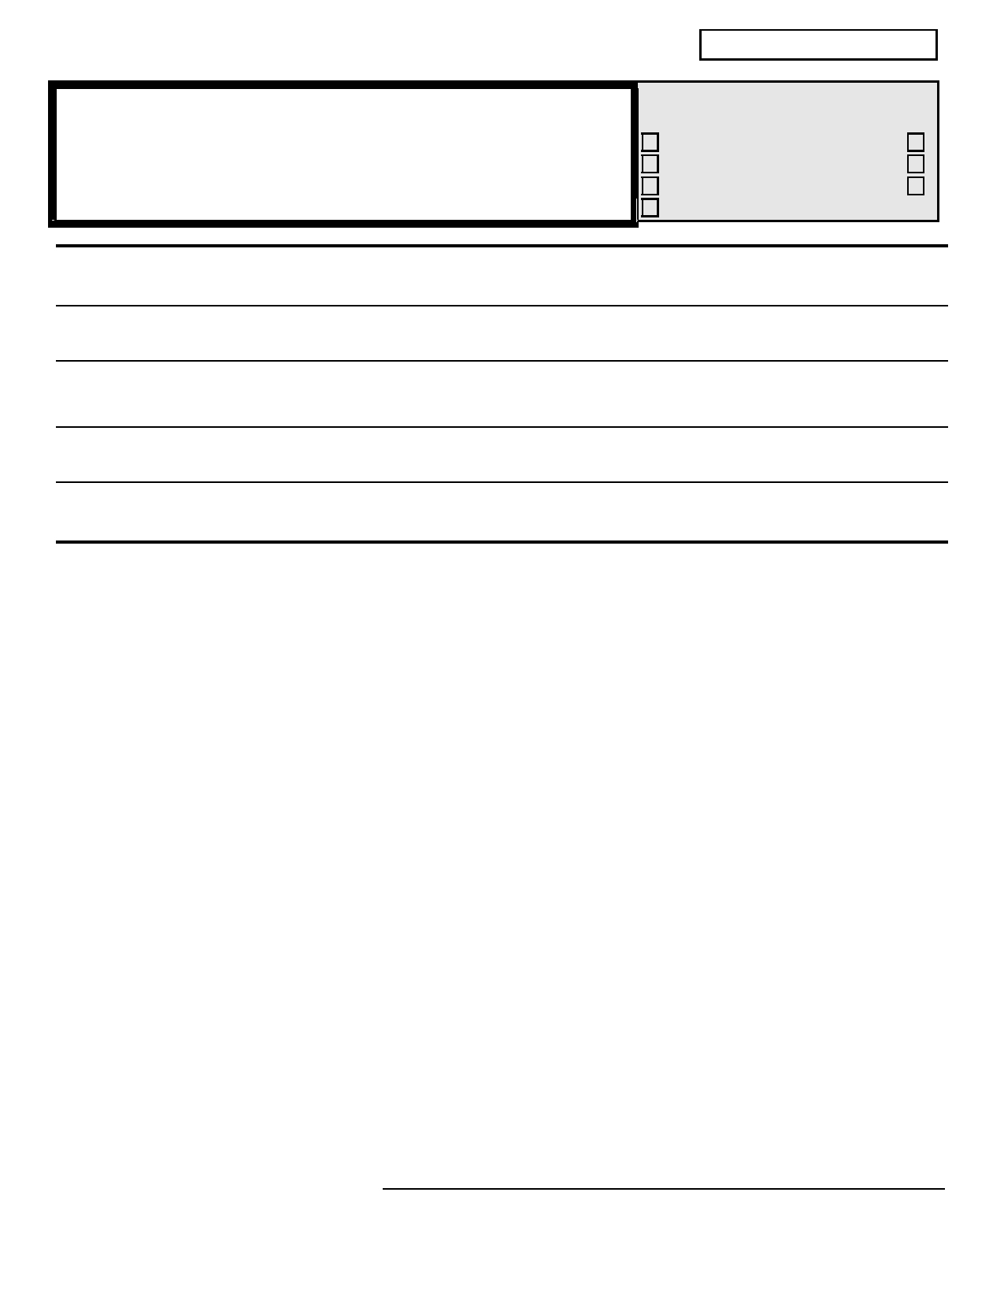
CERTIFIED APPLICATION

Centerville School District #215 Personnel Use Only
2315 Centerville Hwy Ltr. of App. Application
Centerville WA. 98613 Placement File Resume phone: (509) 773-4893 Fax: (509) 773-4902 References Transcripts
Certificate

APPLICATION FOR PROFESSIONAL EMPLOYMENT

Applicant's Full Name
(Last) (First) (M.I.) (Maiden Name)

Other Name(s)
(Please provide any additional information relative to change of name, use of an assumed name, or nickname, necessary to enable a check on your work or school record.)

Present Mailing Address
(Street) (City) (State) (Zip)

Permanent Mailing Address
(Street) (City) (State) (Zip)
Telephone Numbers:
Present: ( ) Permanent: ( ) Work ( )

Social Security Number _________________ (Note: Completion of number is optional. Failure to submit social security
number on this form will not prohibit employment consideration. Social security number may be required on other forms prior to
employment.)

My signature below authorizes the school district to conduct a background investigation and authorizes release of information in
connection with my application for employment. This investigation may include such information as criminal or civil convictions, driving records, previous employers and educational institutions, personal references, professional references, and other appropriate sources.
I waive my right of access to any such information, and without limitation hereby release the school district and the reference source
from any liability in connection with its release or use. This release includes the sources cited above and specific examples as follows:
the local sheriff, information from the Central Criminal Records Exchange of either data on all criminal convictions or certification that no
data on criminal convictions are maintained, information from the Washington or other State Department of Social Services Child
Protective Services Unit and any locality to which they may refer for release of information pertaining to any findings of child abuse or neglect investigations involving me.

Furthermore, I certify that I have made true, correct and complete answers and statements on this application in the knowledge that
they may be relied upon in considering my application, and I understand that any omission, false answered statement made by me on this application, or any supplement to it will be sufficient grounds for failure to employ or for my discharge should I become employed with the school district.

________________________________________________________
Signature of Applicant

________________________
Date

MARK THE APPROPRIATE BOXES INDICATE POSITION(S) DESIRED FOR WHICH YOU ARE ENDORSED

( ) New Application
( ) Previous Application on File

( ) Former Employee of the School District

Are you a U.S. Citizen? ( ) Yes ( ) No
( ) Teacher
( ) Guidance

( ) Other (Explain
___________________
( ) Administrator
( ) Library/Media

__________________

If not, are you eligible to work in the U.S.? List grade level(s) and/or subject area(s) in order of preference:
( ) Yes ( ) No

Rev.6/19/2018
THE CENTERVILLE SCHOOL DISTRICT IS AN EQUAL OPPORTUNITY EMPLOYER

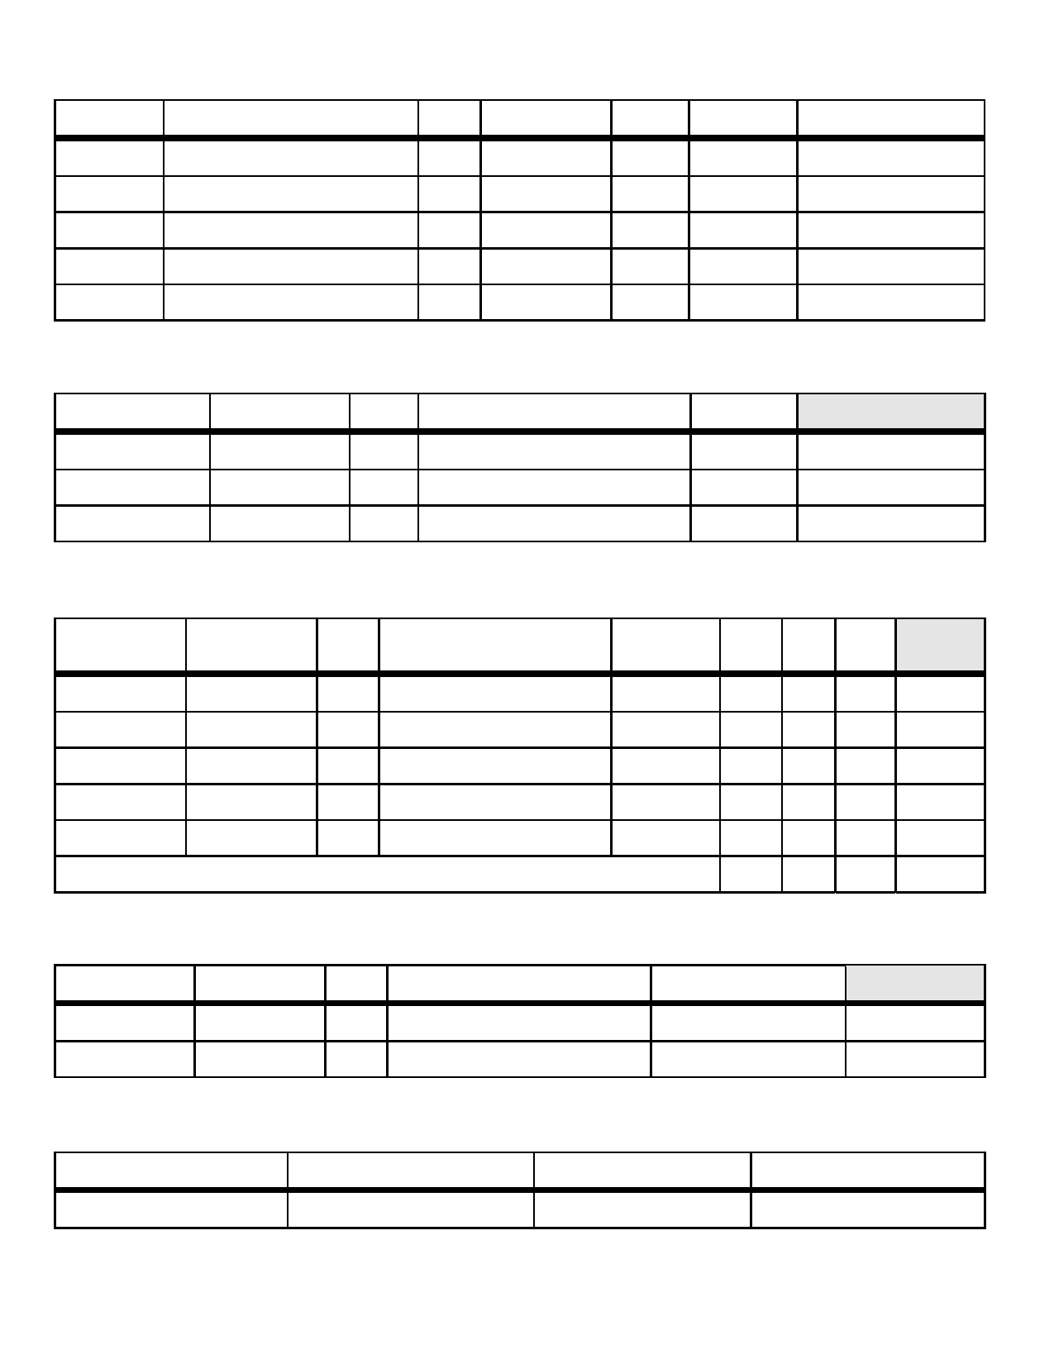
I. EDUCATIONAL AND PROFESSIONAL TRAINING (List chronologically)

Level of Type of Year of Dates of Attendance
Education Name of School or University State Field of Study Degree Graduation From......To

High School
College of
University

II. STUDENT TEACHING EXPERIENCE (List chronologically and include any internships)

School District
Name of School City/County State Grade level and/or Subject Dates Personnel Use

III. TEACHING EXPERIENCE (List chronologically all teaching experience. DO NOT include substitute teaching)

Position Held Dates Full Part
School District Grades and/or Subjects Taught Mo/Day/Yr Total Time Time Personnel
Name of School City/County State (Specify) From...To Years √ √ Use

TOTAL

IV. WORK EXPERIENCE OTHER THAN TEACHING (List chronologically and attach a sheet if necessary)

Employer City/County State Kind of Work Dates of Employment Personnel Use

V. MILITARY EXPERIENCE

Branch of Service Occupational Specialist (MOS) Inclusive Dates Type of Discharge

THE CENTERVILLE SCHOOL DISTRICT IS AN EQUAL OPPORTUNITY EMPLOYER

VI.

A.

B.
CERTIFICATION
If you have been issued a Wash. certificate, please submit a copy... Copy enclosed? .......................No ( ) Yes ( )
Type of Washington Certificate: _____________________________________________________________________
Year of Expiration of Washington Certificate ___________ Endorsement(s) __________________________________
______________________________________________________________________________________________

Have you applied for a WA certificate? No ( ) Yes ( ) When ____ Check if statement of eligibility enclosed ( )

If you have been issued a certificate in another state, please submit copy. Copy enclosed?........................... No ( ) Yes ( )

State ________ Expiration Date__________Certification/Endorsements __________________________________
State ________ Expiration Date_________ Certification/Endorsements __________________________________

VII.
C.
Do you meet the Washington State-No Child Left Behind Highly Qualified Requirement for this position? No ( ) Yes ( )
Please submit documentation of your Highly Qualified status for the core academic area you have applied for.
GENERAL INFORMATION
Month, Day, and Year available for employment _____________ Are you under contract? ......................No ( ) Yes ( )
If yes, where? _______________________ Present Position ______________________________
If presently employed, why do you wish to change? ________________________________________
If under contract, what type: Annual/Probationary ( ) Other ( ) (Explain)____________________
If under contract, have you checked and can you be released if you are offered another position? ...........................No ( ) Yes ( ) If not under contract now, have you ever held a continuing contract in Washington? ................................No ( ) Yes ( )
If yes, cite school district(s) and date(s) _______________________________________________________________
Referral Source: Advertisement/Posting ( ) Employee ( ) Friend ( ) Other (Explain) ________________________

Have you ever been refused tenure or a continuing contract? (If yes, explain on back) .................................. No ( ) Yes ( )

Have you ever been discharged or requested to resign from a position? (If yes, explain on back) ...................... No ( ) Yes ( )
Have you ever been convicted of a violation of law other than a minor traffic violation?
(If yes, explain on back) ......................................................................................................................................................................... No ( ) Yes ( )

Have you ever had a certificate or license revoked or suspended? (If yes, explain on back) ................................ No ( ) Yes ( )

Are any criminal charges or proceedings pending against you? (If yes, explain on back)...................................... No ( ) Yes ( )
Have you been convicted of any offense involving the sexual molestation, physical or
sexual abuse, or rape of a child?(If yes, explain on back) ............................................................................................ No ( ) Yes ( )

VIII.

REFERENCES
It is the applicant's responsibility to have the following information provided the School District in order to be considered for
employment:

A. The names of at least three references sources must be provided and must include current employer if employed, or last
employer if not currently employed.
B. Unless included in Placement File, applicants with work experience must provide recommendations from principals and/or
superintendents from all contracted educational work experiences within the past three years, provide references from last
contracted experience. Applicants who are beginning teachers registered with a college placement office must include
references from their student teaching supervisor(s) and cooperating teacher(s) in the placement file or by listing names below.
C. As indicated above, ( ) a Placement File is being sent, and/or ( ) references are listed below

Name of Reference Position/Relationship Mailing Address Phone Number

THE CENTERVILLE SCHOOL DISTRICT IS AN EQUAL OPPORTUNITY EMPLOYER

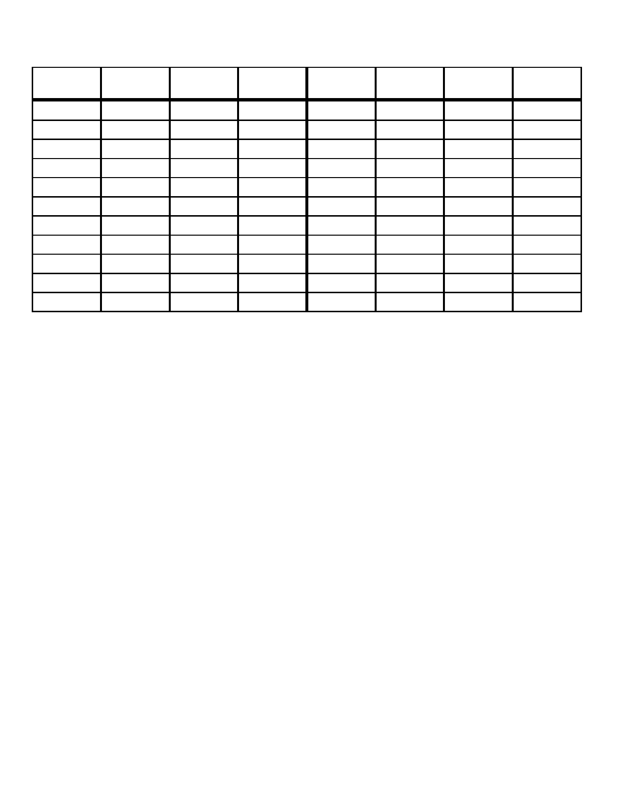
IX. EXTRACURRICULAR ACTIVITIES
Indicate the number of years experience in the activities listed below. Circle activities you are willing to coach/sponsor:

Extra Extra
Curricular High School College Coaching Curricular High School College Contract
Activities Experience Experience Experience Activities Experience Experience Experience

Football Vocal Music

Basketball Athletic Dir.

Baseball Athletic Train.

Softball Drill Team

Track Drama

Cross Cntry Yearbook

Wrestling Newspaper

Golf Student Govt.

Tennis Honor Soc.

Volleyball Clubs

Pep Band Cheerleaders

X. OTHER INFORMATION

To avoid conflict of interest, list any local school board member or employee (relative(s) in the school district and cite relationship:
________________________________________________________________________________________________________ Estimate your total absence from work or school for the last three years and explain the reason(s): __________________________
________________________________________________________________________________________________________
Explain any physical or mental conditions which would adversely affect your ability to perform the duties of the
position you seek; or if there are none, so state: __________________________________________________________________
In your own handwriting, provide any additional information you desire that will afford an additional understanding of
your qualifications. Your goals, objectives, philosophy, and other background factors are of special interest.
________________________________________________________________________________________________________ ________________________________________________________________________________________________________ ________________________________________________________________________________________________________ ________________________________________________________________________________________________________

ADDITIONAL REMARKS AND/OR EXPLANATIONS FROM SECTION VII GENERAL INFORMATION
(attach additional sheet if needed)

________________________________________________________________________________________________________

________________________________________________________________________________________________________

The Centerville School District #215 does not discriminate in any programs or activities on the basis of sex, race, creed, religion, color, national origin, age, veteran or military status, sexual orientation, gender expression or identity, disability, or the use of a trained dog guide or service animal and provides equal access to the Boy Scouts and other designated youth groups. The following employee(s) has been designated to handle questions and complaints of alleged discrimination: Kristin Cameron, Principal 2315 Centerville Hwy, Centerville, WA 98613 (509) 773-4893 kristin@centervilleschool.org

THE CENTERVILLE SCHOOL DISTRICT IS AN EQUAL OPPORTUNITY EMPLOYER

CENTERVILLE SCHOOL DISTRICT

ACADEMIC PREPARATION
Name of Institution | City and State | Dates Attended  From To | Years  Completed | Degrees  And Date | Major &  Minor
High School:
College or University:
Graduate Work:

CERTIFICATES/LICENSES
List below teaching, ESA, administrative and special certificates held:
Type of Certificate | State | Level/Area | Date Issued | Expiration Date

REFERENCES
Please provide five (5) current references, including supervisors whom you have served under who can be contacted to provide references of your experience, knowledge and abilities for the position you have applied.
Name Occupation/Company Address Home Phone Business Phone

1.

2.

3.

4.

5.

THE CENTERVILLE SCHOOL DISTRICT IS AN EQUAL OPPORTUNITY EMPLOYER

EMPLOYMENT RECORD
(Include military and volunteer services)
Date  From To | Job Title | Employer  Address, City, State | Supervisor’s  Name & Phone | Reason for  Leaving
(Attach additional sheets, if necessary, using same format)

PERSONAL INFORMATION

Did you ever belong to a Washington State Retirement System? ______________________________________

If yes, name of Retirement System _____________________________________________________________

Dates (from) __________ (to) ___________

U.S. Citizen? __________ If not, are you an alien lawfully authorized to work in the United States? _________
(Persons hired will be required to provide documents verifying identity and authorization to work within three business days of employment)

Do you have any physical, sensory or mental limitations, handicaps or health problems that could prevent you from successfully performing the job for which you are applying? __________ If yes, please explain: ________

Have you been discharged, nonrenewed (excluding RIF) or forced to resign for misconduct or unsatisfactory service from any position? ______________ If yes, please explain: ___________________________________

__________________________________________________________________________________________
Have you been convicted of any crime other than a minor traffic violation or released from prison within the past 7 years? __________ If yes, please explain on a separate sheet of paper. (A conviction record is not necessarily a disqualification for employment.)

THE CENTERVILLE SCHOOL DISTRICT IS AN EQUAL OPPORTUNITY EMPLOYER

